**JUST IN TIME**

**A Mini-Project Report**

**Under**

**Implementation of Technology**

***Submitted by***

**URVASHI VERMA (E048)**

**NIKITA VISPUTE (E050)**

**AMEE VACHHANI (E055)**

**AAYUSHI JAIN** **(E066)**

***Under The Guidance Of***

**Prof. POONAM GUPTA**

***in partial fulfillment for the award of the degree***

***of***

**BACHELOR OF TECHNOLOGY**

**IN**

**COMPUTERS**

**At**



**Mukesh Patel School of Management & Engineering**

**April 2016**

**CERTIFICATE**

This is to certify that the project entitled **JUST IN TIME** is the bonafide work carried out by **URVASHI VERMA, NIKITA VISPUTE, AMEE VACHCHANI & AAYUSHI JAIN** B.Tech (Computer Engineering), MPSTME (NMIMS), Mumbai, during the fourth semester of the academic year 2015-2016, in fulfillment of the requirements for the award of the Degree of Bachelors of Technology as per the norms prescribed by NMIMS. The project work has been assessed and found to be satisfactory.

___________________

POONAM GUPTA

Internal Mentor

_______________________ ________________________

Examiner 1 Examiner 2

________________________

Dean

Dr. Sharad Y. Mhaiskar

**DECLARATION**

We, URVASHI VERMA, NIKITA VISPUTE, AMEE VACHHANI & AAYUSHI JAIN of B.Tech (Computer Engineering), semester- IV, understand that plagiarism is defined as anyone or combination of the following:

1. Un-credited verbatim copying of individual sentences, paragraphs or illustration (such as graphs, diagrams, etc.) from any source, published or unpublished, including the internet.

2. Un-credited improper paraphrasing of pages paragraphs (changing a few words phrases, or rearranging the original sentence order)

3. Credited verbatim copying of a major portion of a paper (or thesis chapter) without clear delineation of who did wrote what.

4. We have made sure that all the ideas, expressions, graphs, diagrams, etc., that are not a result of our work, are properly credited. Long phrases or sentences that had to be used verbatim from published literature have been clearly identified using quotation marks.

5. We affirm that no portion of my work can be considered as plagiarism and we take full responsibility if such a complaint occurs. We understand fully well that the guide of the seminar/ seminar report may not be in a position to check for the possibility of such incidences of plagiarism in this body of work.

Signature of the Students:

Name: URVASHI VERMA NIKITA VISPUTE AMEE VACHHANI AAYUSHI JAIN

Roll No. E048 E050 E055 E066

Place: Mumbai

Date: March 2016

**Table of contents**

**CHAPTER NO. TITLE PAGE NO.**

Abstract

1. INTRODUCTION 1.

1.1 Problem Specification 1.

1.2 Solution Outline 1.

1.3 Application or usage 1.

2. SYSTEM ANALYSIS 3.

2.1 Software Requirement 3.

2.2 Hardware Specification 3.

3. DESIGN AND METHODOLOGY 4.

3.1 Flowchart 6.

3.2 Output 6.

4. CONCLUSION & FUTURE SCOPE 10.

5. REFERENCES 11.

**ABSTRACT**

The name of our project is ‘**JUST IN TIME**’. This is an Android application developed using Android Studio 1.5 software. Our project comes with a simple and easy to use interface that allows the user to schedule a message to be sent to an individual or to a selected group of people at a particular date and time and post it at a specific time. The message will be delivered at a specific time according to the person posting the information.

In a normal message application, we can only type a message and then either save it as a draft or send it to the particular person at that specific time. Thus the idea of creating this application is so that the user can type the message to be sent at the moment he/she remembers it and schedule it to be sent at a suitable time and date which may or may not be at that very moment.

Today most people have smartphones and the operating system used most popularly worldwide is Android. Thus we have created this application using the Android operating system so that most users can easily download and use the application.

Also, a lot of people tend to cultivate better and friendly relations with their customers and enhance their businesses. Rather than actually sitting and typing the entire messages for them, all we need to do with this app is enter the time, date and type the message in advance and just relax. It will be delivered whenever required. Many-a-times we may be busy and not get time or we may forget to put forward our greetings at the desired time. This app helps us to overcome all those times very easily and comfortably.

**1. INTRODUCTION**

1.1 **PROBLEM SPECIFICATION**

Many a times it was found out that the users forgot to send a message at a particular date or time which may including sending greetings to an individual or a group of professionals. It might also be a timely reminder sent to a group of people about an upcoming event or program. Therefore, it was needed to design a scheduler which included necessary details like date and time and how many times the reminder has to be sent, to whom choosing between an individual or a group of people or to be broadcasted to a group.

1.2 **SOLUTION OUTLINE**

Message scheduler is an android application that allows people to schedule messages to be sent at that moment or in the near future. Also if they want to use an already defined message called a template to be sent after modification.

1.3 **APPLICATION/USAGE**

In this application the users will be able to draft a message and set a specific date and time for the message to be sent. The user can either select the message to be sent to a particular person or group of people.

For example if a user wants to wish his/her friend on their birthday or anniversary sharp at 12.00 am, then he/she can schedule the message to be sent at that time on that particular day without having to worry later if he/she forgets.

Another example could be to schedule a meeting. Here the manager can schedule a message to call for a meeting of all employees of a particular department at a particular time on a specific day and have it sent to only the required department people and not the entire staff in the office.

Thus there is ease of drafting a message as and when the user remembers as well as saving and scheduling it to be delivered later.

In this app all the common messaging features exist like adding a template, adding an emoji icon, saving the draft, directly being able to access the phone contacts while inputting the recipient data along with the most important feature of scheduling.

Nowadays most people worldwide use Android operating system on their smartphones. Thus we have created our application using Android Studio 1.5 software so that most users looking for an SMS scheduling application can easily download and use it.

**2 .SYSTEM ANALYSIS**

2.1 **SOFTWARE REQUIREMENTS**

* **OPERATING SYSTEM REQUIREMENTS**

1. Android Lollipop 5.1 or higher

* **PERMISSIONS**

1. Access to internal storage.
2. Permissions to change notification policy

2.2 **HARDWARE SPECIFICATIONS**

Since the application is developed to run in an Android environment the most basic hardware requirement that we have selected for this app is an Android Device running Lollipop Version 5.1

The other hardware specifications are-

* Minimum 512 MB RAM
* Ample internal storage within the device.

**3. DESIGN & METHODOLOGY**

The application is a simple tool for automatic text messages which can be sent to specified number of people and a particular time. The user can choose the recipients from the contacts database of his phone as that will be linked with the application. It may be used as a broadcast as well.

**MAIN FEATURES**

* Recipients can be typed in directly or selected from contacts of the phone as the app and the contacts database is linked.
* Multiple recipients can be chosen.
* Flexible scheduling system - user can send sms once, every 5 minutes, 15 minutes, every hour, etc as per his/her choice.
* Sent sms messages are added to the proper conversation threads.
* Status bar notifications are triggered for sent messages and delivery reports
* History of sent and delivered messages is available
* To be able to use available templates or add new ones.
* Make groups of selected people if needed.
* To be able to add a voice note into the message.

The application is used to schedule messages and send them at the set time. Hence the user has a set of predefined messages i.e. templates. The user can use these message and also create templates of his own and add to the list of templates.

We have linked the application to the contacts on the phone/ device. Hence when the user types the recipient’s name suggestions are shown in a dropdown depending on the characters types y the user. These will appear from the phone’s database. The user also has an option to select the contacts directly. Hence using the icon next to the recipients tab the user can select contacts directly from the database.

When the user has typed a message they will next have to click on the time and dates tab. This tab will open another activity where the user can choose the desired time and date for scheduling the message. Hence the message will be delivered from the user’s device at the specified time. In case the user doesn’t select the time and date explicitly, the message will be scheduled immediately and will leave the user’s device as soon as they hit the ‘schedule’ tab.

The user can view all their activities on another page. That is the user can see also the messages that have been scheduled and will be sent. All the messages that have been sent and all the messages that have been saved as a draft. The messages that have been saved as draft and the messages that have been scheduled to be sent will also have a function to delete the message.

The user can also create groups on the application. This feature can be used if the user wants to send a particular message to a certain set of people. The user can use this option by selecting the tab at the top right corner, next to the ‘create new message’ tab. Then select manage groups followed by add group. As soon as these steps have been completed the user can then choose contacts to be added to the group from the contacts page. Followed by this the user shall be asked to name the group, then save the group. The user can always go to the group and edit the members of the group by adding or removing the existing members. Any number of groups can be made.

A few additional features include default emojis which when clicked on to add to the message will add the code for the same. A voice note feature will also be added, which can be sent along with the message to increase the richness of communication. A repeat feature is to be added which will enable the user to send the message periodically if required.

3.1 **FLOWCHART**

TO SCHEDULE AN SMS IN THE APP:

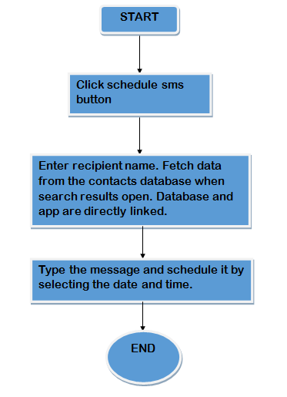

3.2 **OUTPUT**

Step 1: Download the app. First page. If the user selects schedule message option without entering a valid message or recipient name.

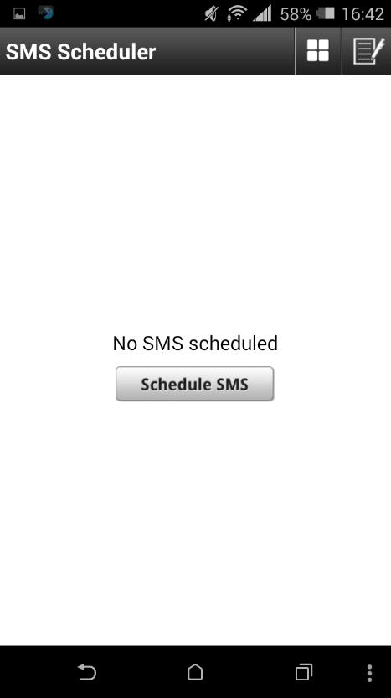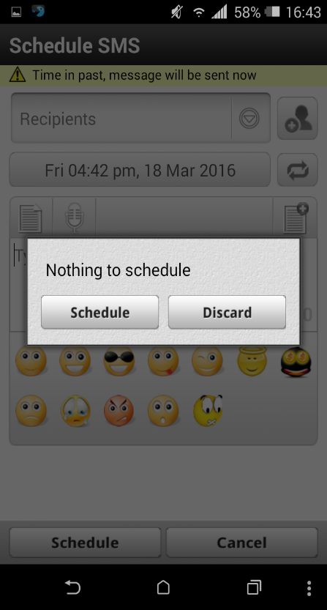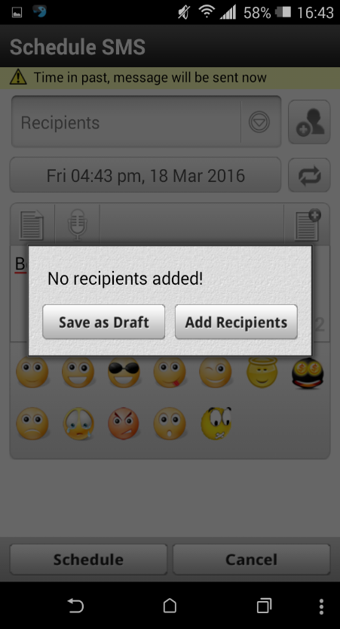

Step 2: Draft a new message, Contacts Database search results.

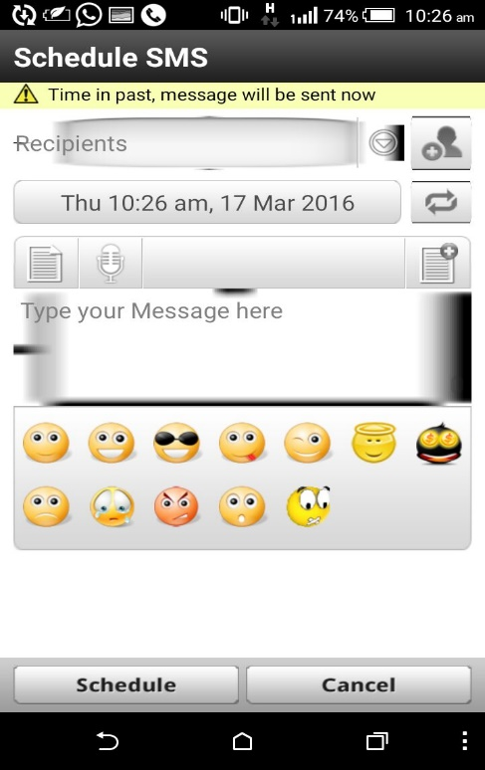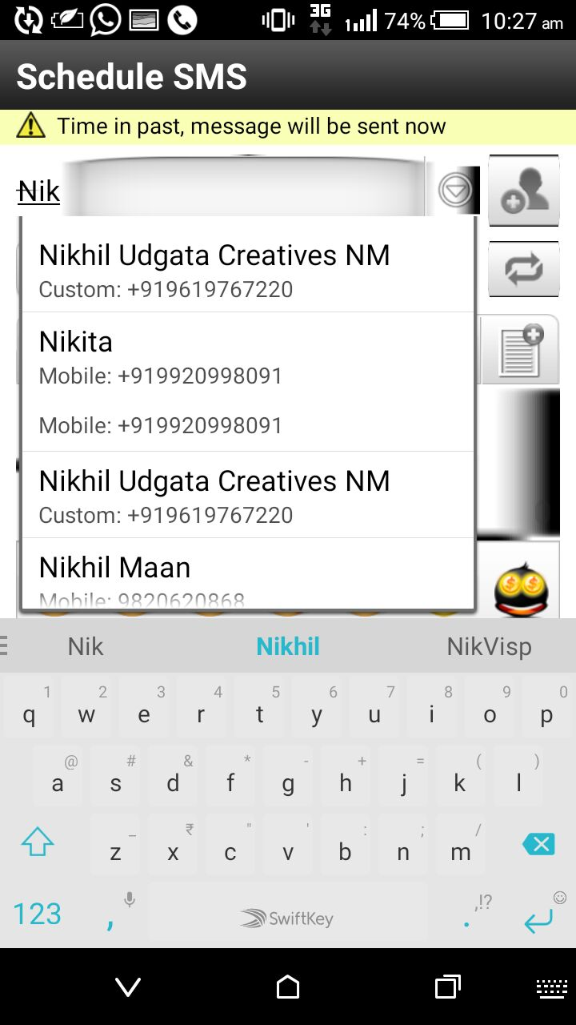

Step 3: Templates.

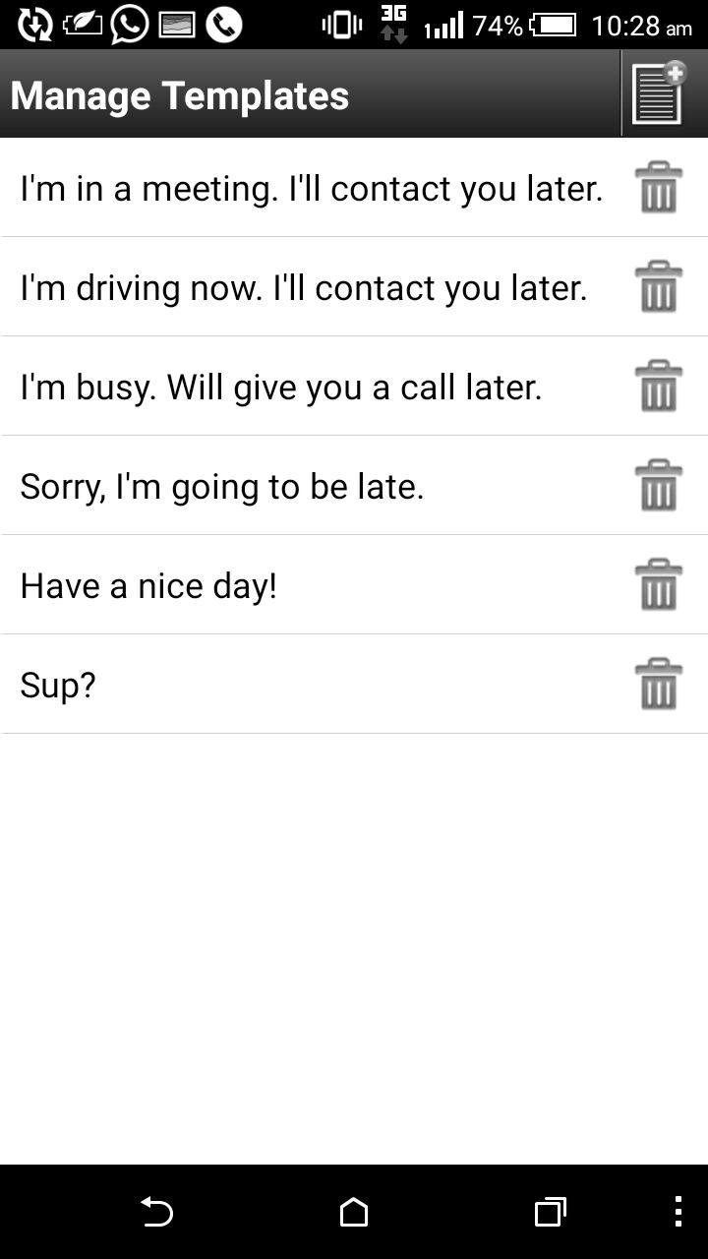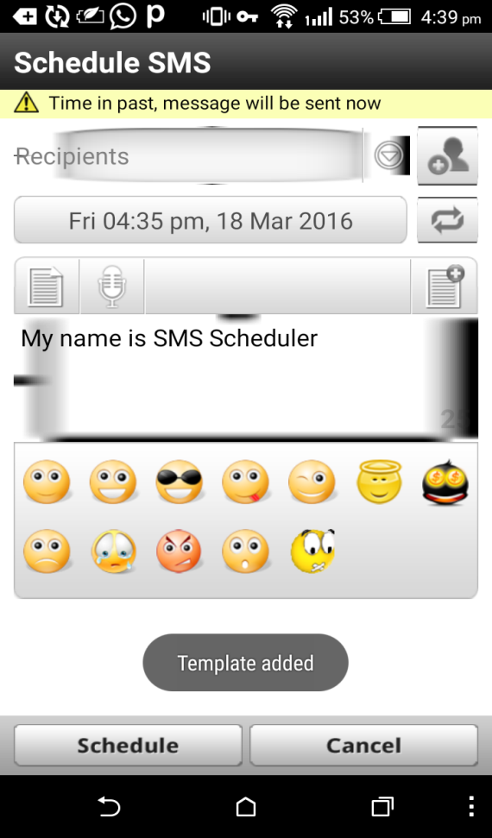

Step 4: Schedule SMS

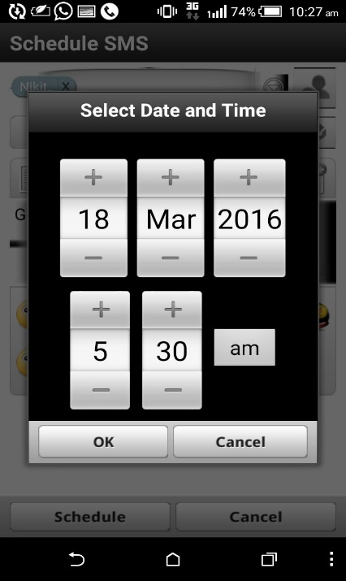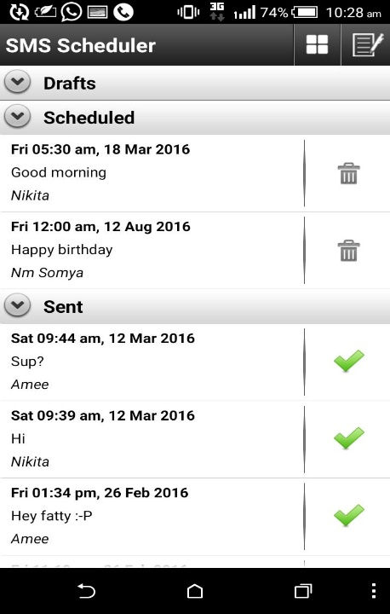

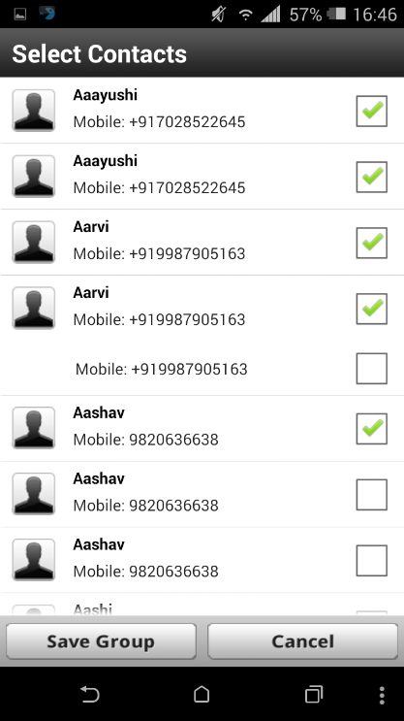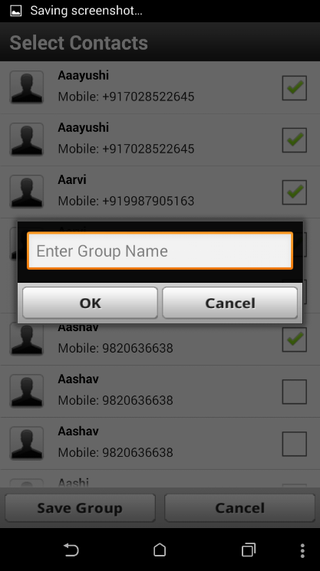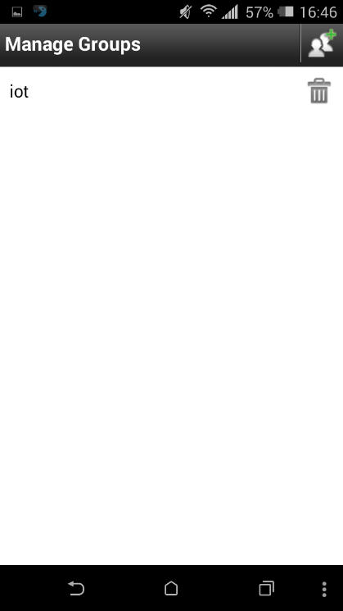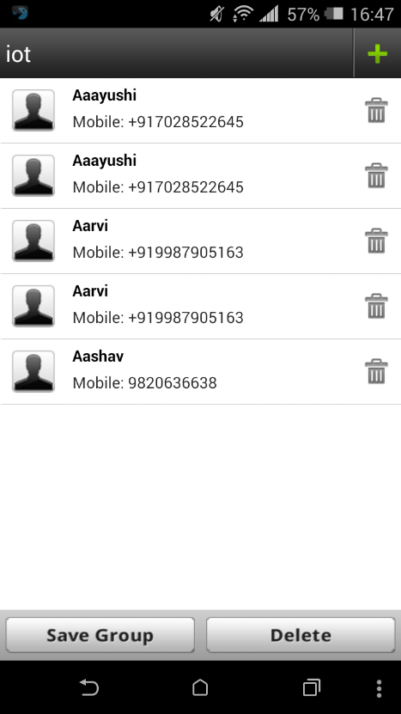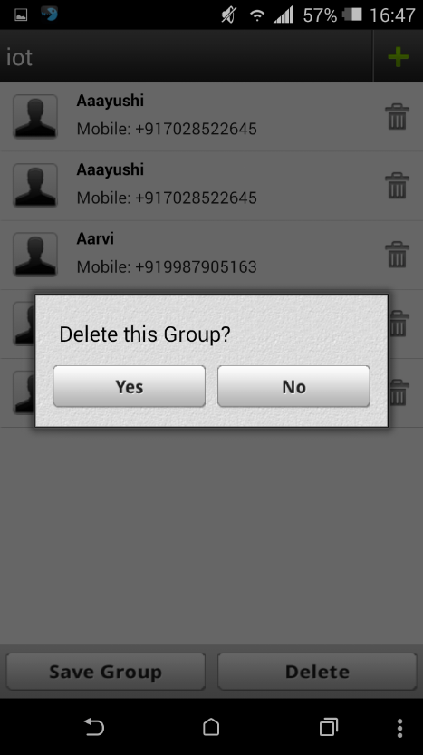

**4. CONCLUSION & FUTURE SCOPE**

Functionalities such an embedding of voice notes in the messages can enhance the functionality of the application. Along with text messages we are planning to try an schedule emails as well hence this app can provide an all round professional functionality.

**5. REFERENCES**

|  |  |
| --- | --- |
| [**https://www.youtube.com/user/ProgrammingKnowledge/videos**](https://www.youtube.com/user/ProgrammingKnowledge/videos) | **04/02/16-16/04/16** |
| [**http://developer.android.com/reference/javax/xml/parsers/SAXParser.html**](http://developer.android.com/reference/javax/xml/parsers/SAXParser.html) | **10/03/16-16/04/16** |
| [**http://www.tutorialspoint.com/android/android_sqlite_database.htm**](http://www.tutorialspoint.com/android/android_sqlite_database.htm) | **02/03/16-16/04/16** |